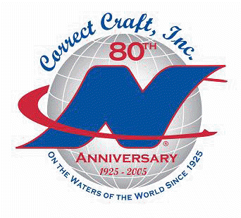
RECALL NOTICE

CUSTOMER LABEL HERE March 31, 2005
Address
City, ST zip

Dear Correct Craft Owner,

In keeping with the provisions of the Federal Boat Safety Act of 1971, Correct Craft, Inc. hereby advises you that we have informed the U.S. Coast Guard (U.S.C.G.) that we are initiating a RECALL on 282 of our 2005 model SV211 boat. According to our database, you own a boat included in this Recall (the hull number of your boat is noted on the label above).

This issue developed due to an oversight in a design change to the product. It was our intent to switch the functions of our rear vents, making the starboard vent exhaust by moving the blower outlet to that side. However, this inadvertently mixed intake and exhaust ducts at the starboard vent, putting the boats in conflict with U.S. Coast Guard standards (ABYC paragraph H-2.6.3.2.6). This existing ventilation arrangement may not properly eliminate fumes from leaking fuel, creating the potential of a fire and/or explosion. We have taken corrective action in our production process.

We regret this situation and apologize for any inconvenience. Please contact your nearest Correct Craft dealer immediately to arrange for the Recall service.

NOTE: if not the current owner of this boat please refer to the box at the bottom of this page.

It is our intention to manage this Recall efficiently to serve you as we fulfill U.S.C.G. regulations. We have rearranged responsibilities to coordinate this recall successfully. Thank you for your patience and your cooperation.

Respectfully submitted,
Correct Craft, Inc.

IF YOU ARE NOT THE OWNER OF THIS BOAT, PLEASE EITHER COMPLETE AND FAX THIS INFORMATION TO 407/851-7844 OR
CONTACT CUSTOMER SERVICE AT 1-800-346-2092 OR ski@correctcraft.com.

NO, I AM NOT THE OWNER OF THIS BOAT ________.

CURRENT OWNER IS: name ________________________________ address___________________________________________

city _________________________________ state/zip code ______________________________________

phone #

