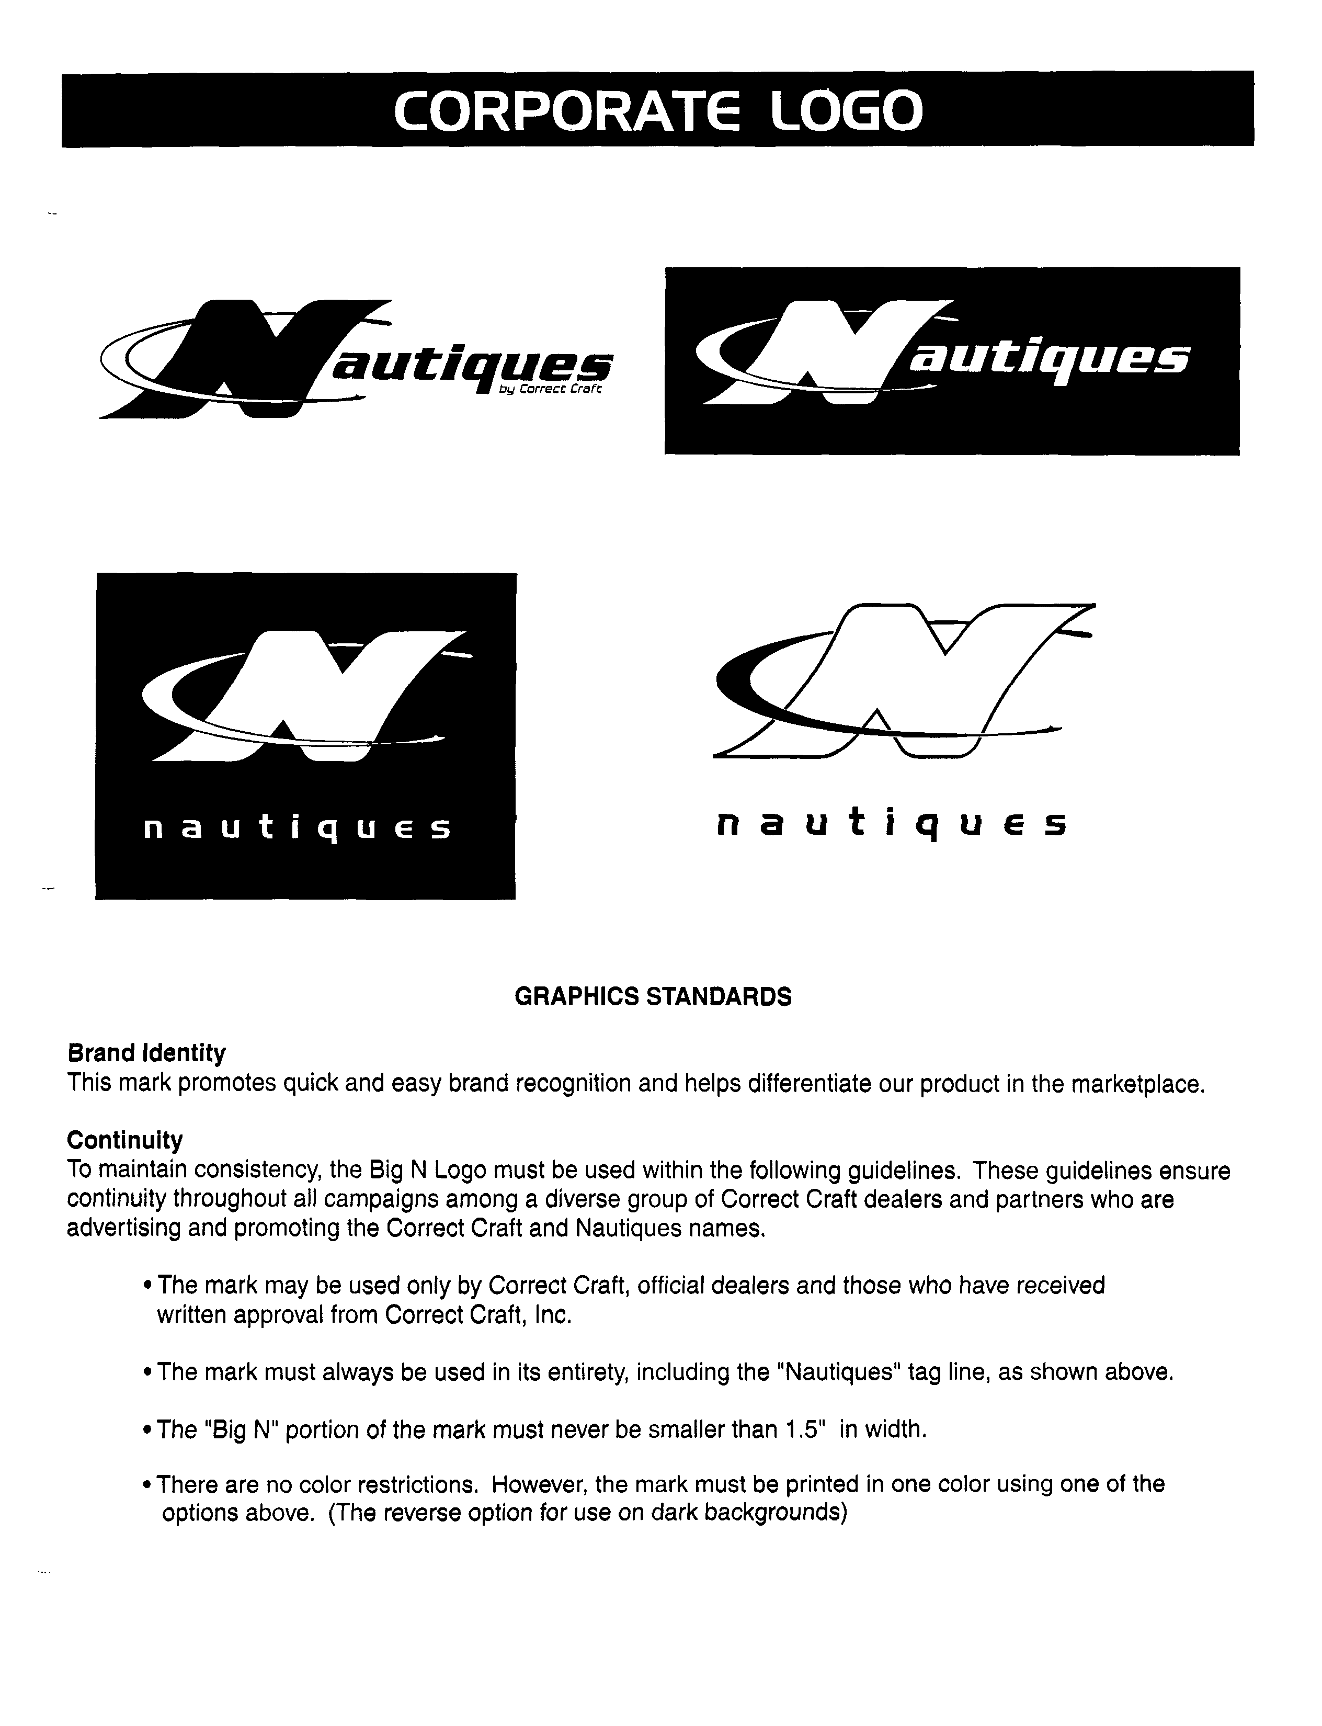
RECALL NOTICE

June 24, 2004

Dear Correct Craft Owner,

In keeping with the provisions of the Federal Boat Safety Act of 1971, Correct Craft, Inc. hereby advises you that we have informed the U.S. Coast Guard (USCG) that we are initiating a RECALL campaign involving the bolt in the steering clamp post in select 2003 and 2004 model boats. According to our database you own a boat included in this Recall (the hull number of your boat is noted on the label above).

This effort is based upon research of in-house inventory and finished boats, feedback from the clamp assembly manufacturer (TeleflexMorse), and inspection of boats in the field. From our research, we have found some bolts that can be threaded and unthreaded by hand with no resistance/friction from the “patch-lock”. It appears that the “patch-lock” chemical on the bolt is an insufficient amount and/or is not performing as intended on every bolt. The potential exists, if not corrected, for the bolt to back out of the post and disengage the post causing loss of steering control, an unsafe situation for the boat occupants that could lead to injury.

We regret this situation and apologize for any inconvenience. The marine industry has been using this bolt assembly for over twenty-five years with no problems. To prevent future concerns the following steps have been taken:
- TeleflexMorse is confirming the reliability of the “patch-lock” on future components.
- Correct Craft has instituted a new procedure to add Loc-tite 271 to the bolt at installation.
- A “Critical Point” check in manufacturing the boats now includes confirming a secure installation of this bolt, as well as others.

Please contact your nearest Correct Craft dealer immediately to arrange for the Recall service.

NOTE: if not the current owner of this boat please refer to the box at the bottom of this page.

It is our intention to manage this Recall efficiently to serve you as we fulfill USCG regulations. We have added staff and rearranged responsibilities to coordinate this recall successfully. We trust that these and other steps taken will reinforce our commitment to stand behind the product you bought.

Respectfully submitted,
Correct Craft, Inc.

IF YOU ARE NOT THE OWNER OF THIS BOAT, PLEASE EITHER COMPLETE AND FAX THIS INFORMATION TO 407/851-7844 OR
CONTACT CUSTOMER SERVICE AT 1-800-346-2092 OR ski@correctcraft.com.

NO, I AM NOT THE OWNER OF THIS BOAT ________.

CURRENT OWNER IS: name ________________________________ address___________________________________________

city _________________________________ state/zip code ______________________________________

phone #

6100 South Orange Ave. * Orlando, Florida 32809 * Phone 407/855-4141

